Christopher King
2018141521058
Mechanical Design 1
Class Section 01
11/28/2020

Problem 1
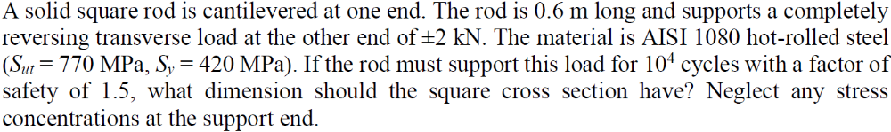
Solution:
For this question, we are asked to determine what dimension should the square cross section have.
$$M_{max}=\left(2000 N\right)×\left(0.6 m\right)=1200 N∙m$$
$$σ_{max}=\frac{Mc}{I}=\frac{M\left(\frac{b}{2}\right)}{\frac{bb^{4}}{12}}=\frac{6M}{b^{3}}=\frac{7200}{b^{3}} Pa$$

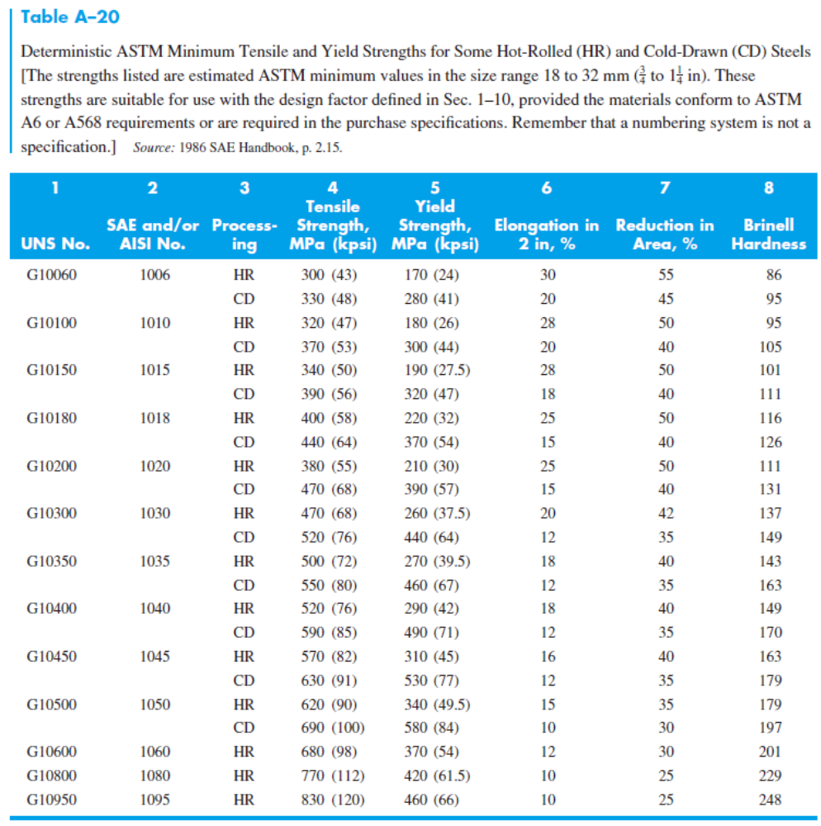
$$S_{ut}=770 MPa⇒\left\{\begin{aligned}S_{e}^{'}=0.5S_{ut}=0.5×\left(770 MPa\right)=385 MPa \\ Figure 6.18: f=0.83\end{aligned}\right.$$
$$S_{y}=420 MPa$$
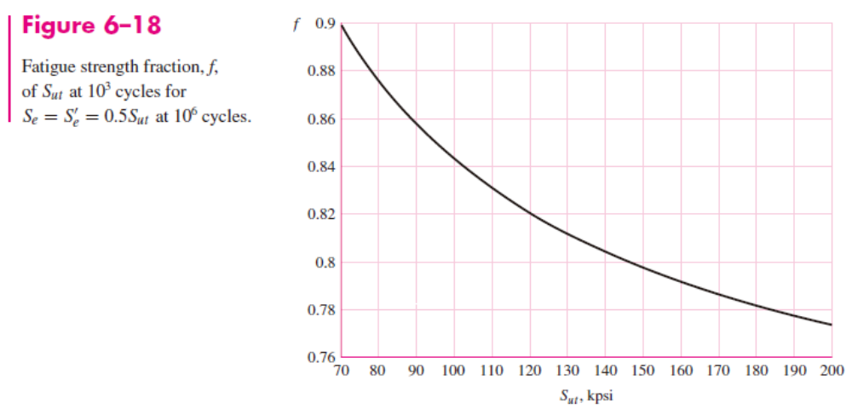
Assume:
$$k_{b}=0.85$$
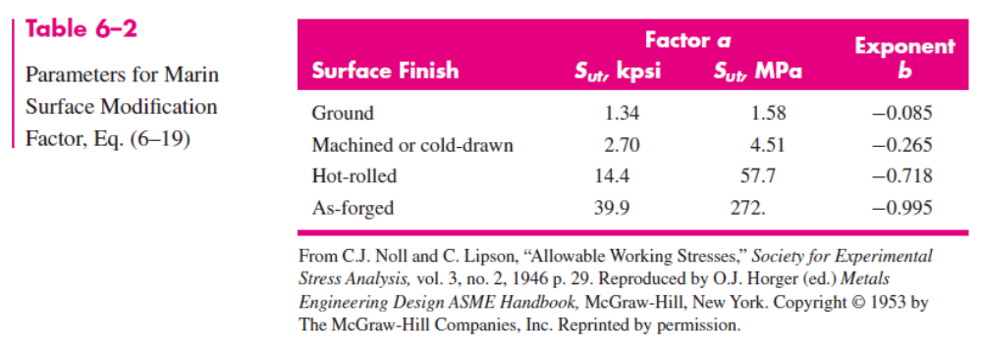
And from the question and Table 6-2, I can know that
$$k_{a}=aS_{ut}^{b}=57.7×{\left(770 MPa\right)}^{-0.718}=0.488$$
Therefore,
$$S_{e}=k_{a}k_{b}S_{e}^{'}=\left(0.488\right)×\left(0.85\right)×\left(385 MPa\right)=159.79 MPa$$
$$a=\frac{{\left(fS_{ut}\right)}^{2}}{S_{e}}=\frac{{\left[\left(0.83\right)×\left(770 MPa\right)\right]}^{2}}{\left(159.79 MPa\right)}=2256 MPa$$
$$b=-\frac{1}{3}\log\left(\frac{fS_{ut}}{S_{e}}\right)=-\frac{1}{3}\log\left[\frac{\left(0.83\right)×\left(770 MPa\right)}{\left(159.79 MPa\right)}\right]=-0.2007$$
$$S_{f}=aN^{b}=\left(2256 MPa\right)×{\left({10}^{4}\right)}^{-0.2007}=402.6 MPa$$
$$FS=\frac{S_{f}}{σ_{max}}=\frac{\left(402.6 MPa\right)}{\left(\frac{7200}{b^{3}} Pa\right)}=1.5$$
$$⇒b=0.0299 m$$
$$⇒b=30 mm$$
Verify:
$$d_{e}=0.808{\left(hb\right)}^{\frac{1}{2}}=0.808b=24.24 mm$$
$$k_{b}={\left(\frac{d}{7.62}\right)}^{-0.107}={\left(\frac{24.24 mm}{7.62}\right)}^{-0.107}=0.88$$
$$σ_{max}=\frac{7200}{{\left(30 mm\right)}^{3}}=267 MPa$$
$$n_{y}=\frac{S_{y}}{σ_{max}}=\frac{420 MPa}{267 MPa}=1.57$$
This is suitable.

Problem 2
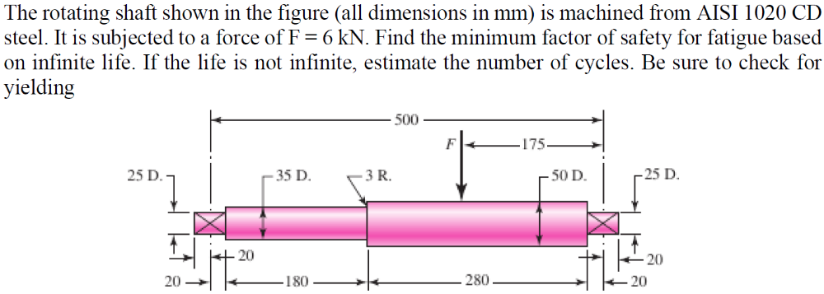
Solution:
For this question, we are asked to find the minimum factor of safety for fatigue based on infinite life. If the life is not infinite, estimate the number of cycles. Be sure to check for yielding.
$$σ_{max}=\frac{Mc}{I}=\frac{\left(2.1 kN\right)×\left(200 mm\right)×\left[\frac{\left(35 mm\right)}{2}\right]}{\frac{π×{\left(35 mm\right)}^{4}}{64}}=99.78 MPa$$
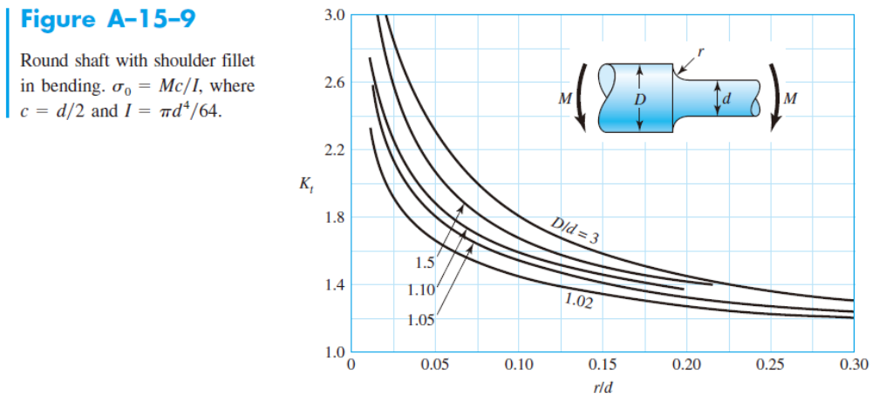
$$\left\{\begin{aligned}\frac{r}{d}=\frac{3 mm}{35 mm}=0.76 \\ \frac{D}{d}=\frac{50 mm}{35 mm}=1.43\end{aligned}\right.⇒K_{t}=1.7$$
$$S_{ut}=470 MPa=68 kpsi$$
$$S_{y}=390 MPa$$
$$\sqrt{a}=0.246-3.08×{10}^{-3}×S_{ut}+1.51×{10}^{-5}×S_{ut}^{2}-2.67×{10}^{-8}×S_{ut}^{3}=0.246-3.08×{10}^{-3}×\left(68 kpsi\right)+1.51×{10}^{-5}×{\left(68 kpsi\right)}^{2}-2.67×{10}^{-8}×{\left(68 kpsi\right)}^{3}=0.09771$$
$$q=\frac{1}{1+\frac{\sqrt{a}}{\sqrt{r}}}=\frac{1}{1+\frac{0.09771}{\sqrt{0.118}}}=0.778$$
$$K_{f}=1+q\left(K_{t}-1\right)=1+\left(0.778\right)×\left(1.7-1\right)=1.54$$
$$S_{e}^{'}=0.5S_{ut}=0.5×\left(470 MPa\right)=235 MPa$$
And from the question and Table 6-2, I can know that
$$k_{a}=aS_{ut}^{b}=4.51×{\left(470 MPa\right)}^{-0.265}=0.883$$
$$k_{b}={\left(\frac{d}{7.62}\right)}^{-0.107}={\left(\frac{35 mm}{7.62}\right)}^{-0.107}=0.849$$
$$k_{c}=1$$
Therefore,
$$S_{e}=k_{a}k_{b}k_{c}S_{e}^{'}=\left(0.883\right)×\left(0.849\right)×\left(1\right)×\left(235 MPa\right)=176.32 MPa$$
$$n_{f}=\frac{S_{e}}{K_{f}σ_{max}}=\frac{\left(176.32 MPa\right)}{\left(1.54\right)×\left(99.78 MPa\right)}=1.14$$

Problem 3
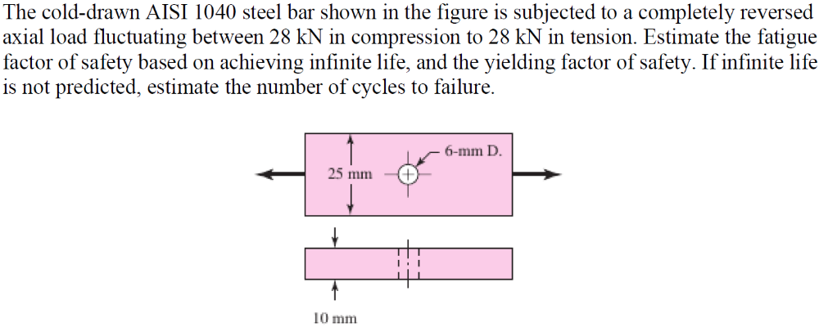
Solution:
For this question, we are asked to estimate the fatigue factor of safety based on achieving infinite life, and the yielding factor of safety. If infinite life is not predicted, estimate the number of cycles to failure.
$$S_{ut}=590 MPa=85 kpsi$$
$$S_{y}=490 MPa$$
$$σ_{max}=\frac{F_{max}}{A}=\frac{\left(28 kN\right)}{\left(10 mm\right)×\left[\left(25 mm\right)-\left(6 mm\right)\right]}=147.37 MPa$$
$$n_{y}=\frac{S_{y}}{σ_{max}}=3.32$$
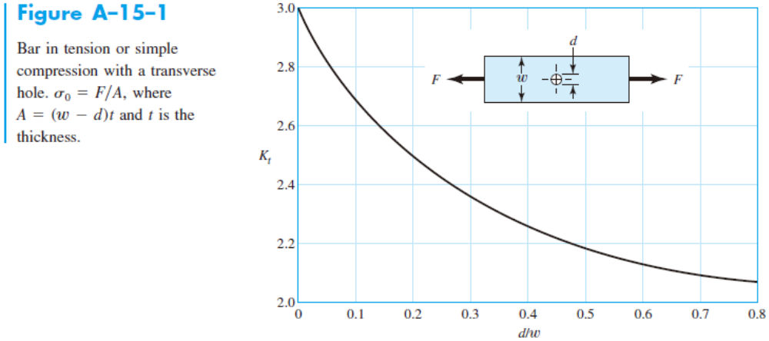
$$\frac{d}{w}=\frac{6 mm}{25 mm}=0.24$$
$$⇒K_{t}=2.44$$
$$S_{e}^{'}=0.5S_{ut}=0.5×\left(590 MPa\right)=295 MPa$$
And from the question and Table 6-2, I can know that
$$k_{a}=aS_{ut}^{b}=4.51×{\left(590 MPa\right)}^{-0.265}=0.832$$
$$k_{b}=1$$
$$k_{c}=0.85$$
Therefore,
$$S_{e}=k_{a}k_{b}k_{c}S_{e}^{'}=\left(0.832\right)×\left(1\right)×\left(0.85\right)×\left(295 MPa\right)=208.5 MPa$$
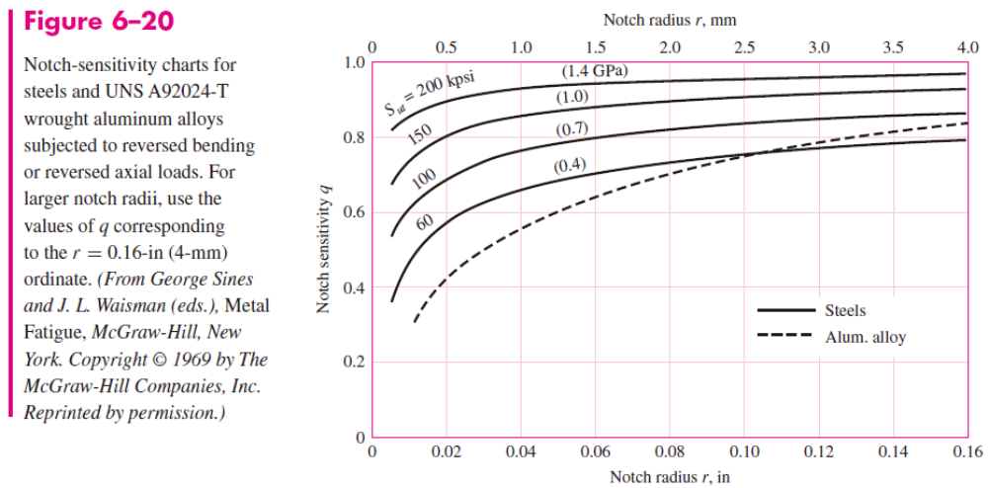
Figure 6-20:
$$q=0.83$$
$$K_{f}=1+q\left(K_{t}-1\right)=1+\left(0.83\right)×\left(2.44-1\right)=2.1952$$
$$σ_{a}=K_{f}\left|\frac{F_{max}-F_{min}}{2A}\right|=\left(2.1952\right)×\left|\frac{\left(28 kN\right)-\left(-28 kN\right)}{2×\left(10 mm\right)×\left[\left(25 mm\right)-\left(6 mm\right)\right]}\right|=323.5 MPa$$
$$σ_{m}=K_{f}\left|\frac{F_{max}+F_{min}}{2A}\right|=\left(2.1952\right)×\left|\frac{\left(28 kN\right)+\left(-28 kN\right)}{2×\left(10 mm\right)×\left[\left(25 mm\right)-\left(6 mm\right)\right]}\right|=0 MPa$$
$$\frac{1}{n_{f}}=\frac{σ_{a}}{S_{e}}+\frac{σ_{m}}{S_{ut}}⇒n_{f}=\frac{S_{e}}{σ_{a}}=0.64$$
$$f=0.87$$
$$a=\frac{{\left(fS_{ut}\right)}^{2}}{S_{e}}=\frac{{\left[\left(0.87\right)×\left(590 MPa\right)\right]}^{2}}{\left(208.5 MPa\right)}=1263.6 MPa$$
$$b=-\frac{1}{3}\log\left(\frac{fS_{ut}}{S_{e}}\right)=-\frac{1}{3}\log\left[\frac{\left(0.87\right)×\left(590 MPa\right)}{\left(208.5 MPa\right)}\right]=-0.1304$$
$$N={\left(\frac{σ_{rev}}{a}\right)}^{\frac{1}{b}}={\left[\frac{\left(323.5 MPa\right)}{\left(1263.6 MPa\right)}\right]}^{\frac{1}{-0.1304}}=34000$$

